**Table of Contents**

1.0 Overview

1.1 Key Features

1.2 Project Points

2.0 UI Flow and Functionality

2.1 Logos and Cert Info

2.2 Splash Page

2.3 Front-End Menus

2.3.1 Main Menu

2.3.1.1 Continue Game

2.3.1.2 New Game

2.3.1.3 Load Game

2.3.1.4 Settings

2.4 In-Game Menus

2.4.1 Pause Menu

2.4.2 Character Menu

2.4.3 Save Screen

3.0 General Game Structure

3.1 Level Loading Screen

3.2 Level Intro Story

3.3 Gameplay

3.4 The Boss Fight

3.5 Victory Screen

4.0 Game Type Descriptions

4.1 Objective

6.0 Allies/Enemies

7.0 Controls & Mappings

7.1 Menu Control

8.0 Locations

9.0 Assets

9.1 Player

9.2 Enemies

9.3 Weapons

9.4 Armors

9.5 Player HUD

9.6 Environment

9.7 UI / Menu Sounds

9.8 Music

9.9 Generic Level Assets / Sounds

# **1.0 Overview**

*Legend of Zelda: Dawn of Fire* is a 3D, 3rd-Person tactical-action conquest game. Players will take a growing army of conquered allies on a campaign of conquest through Hyrule, sacking villages, fortresses, and temples. On the battlefield, players use their allied troops as weapons on the fly: selecting units, pulling them out of play as energy, then ‘firing’ them as different and specific attack formations.

## 1.1 Key Features

**1.1.2** Powerful Attacks

· As a villain, play is all about power, and the player leaves very big footprints; all of the player’s activities are big, broad, and effective. The player will storm into an arena with a small army at their back, using their troops as literal weaponry for big, sweeping attacks, and defending themselves with a giant broadsword.

**1.1.3** Battlefield Control

· Players have a toolset of simple, core abilities which allow them to almost instantly read the battlefield and affect the course of action: troop types are visually coded, the HUD conveys the necessary information at all times, an overhead map menu is easily accessible, the pull-and-direct troop manipulation allows near-instant tactical adjustments.

**1.1.4** Fantastical Environments

· The set-pieces in Hyrule are varied in geography and size, with everything from small valley villages to cavernous underground fortresses to tree-top temples.

**1.1.5** Conquest Leveling

· Players add to their growing army by defeating enemies and enslaving them by magic; different creatures have different attacks and behaviors, and each type acts uniquely as the player’s pull-and-direct magical attacks. Players unlock new magical attacks by gaining more of that type of ally, and using that type more in battle.

## 1.2 Project Points

1.2.1 Release Date: TBD

1.2.2 ESRB Rating: T 13+

1.2.3 Target Platforms: Wii U

1.2.4 Audience: Zelda fans, tactical-action fans, teens to young adults

1.2.5 C# Scripts only.

# **2.0 UI Flow and Functionality**

## 2.1 Logos and Cert Info



## 2.2 Splash Page

* Simple Introductory page with the game’s title with only one option for the player
  + The player is prompted to “Press Start”

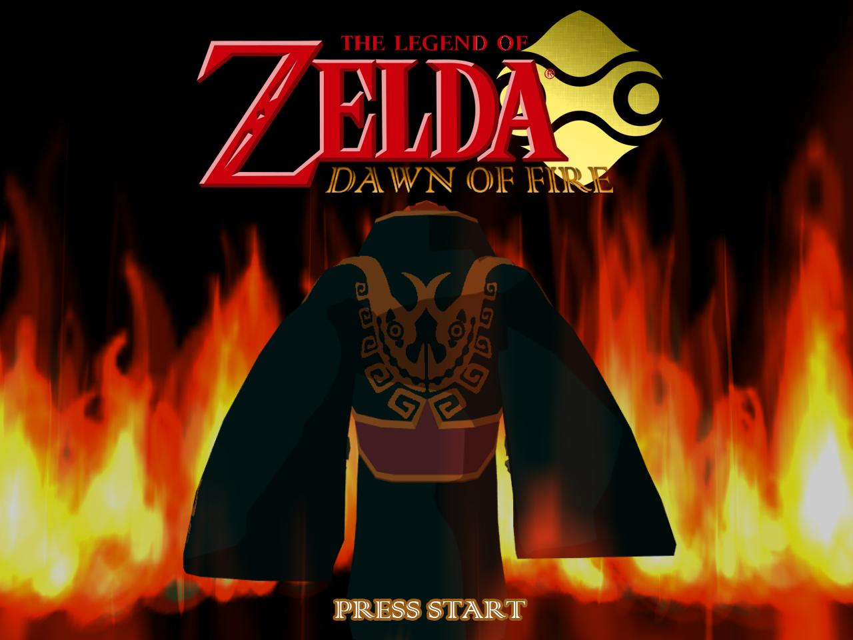

## 2.3 Front-End Menus

Displayed as GUI elements over Splash Page

### 2.3.1 Main Menu

* This menu screen provides a number of options for the player to choose from that can get them started on the game.

### 2.3.1.1 Continue Game

* The Player may select this option to continue playing from where they last were in the game, on the most recently played Profile
  + If the Player has not no data from a previous play session, then this option will be grayed out and will not be selectable

### 2.3.1.2 New Game

* The Player may select this option if they wish to start a new game.
  + This will bring the Player to the Profile selection screen
    - * This option will bring them to the screen that allows them to name the Profile.
      * Players input profile name via a digital keyboard
      * Select “Confirm” to confirm name

### 2.3.1.3 Load Game

* The Player may select this option to load a previously saved game that they may have created during a previous play session
  + When they select this option, it will bring the Player to the load game slot selection screen

### 2.3.1.4 Settings

* Selecting this option will bring the Player to the settings menu which has a number of settings of the game that can be adjusted by the Player
  + Sound
    - Master Volume - A slide bar that raises or decreases the master volume of the game
    - Sound Effects - A slide bar that raises or decreases the sound effects of the game
    - Music - A slide bar that raises or decreases the music volume of the game
  + Controls
    - Allows the Player to see what actions are configured to which buttons and also allows the Player to change the button configuration
  + Difficulty
    - Allows the Player to choose to play the game in Easy, Medium, or Hard difficulty
  + Gamma
    - Allows the Player to adjust the Gamma

## 2.4 In-Game Menus

### 2.4.1 Pause Menu

* The Pause Menu can be activate at any time by pressing the “Start” button on the Wii U Gamepad.
  + Resume Game
    - Allows the Player to resume playing the game once they no longer need it paused. They can also press the “Start” button again to unpause the game
  + Character Menu
    - Allows the Player to see Information about their character
  + Troop Inventory
    - Non-selectable on the Pause Menu on the right hand side of the other options in the Pause Menu
  + Save
    - Directs to Save Screen
  + Load
    - Directs to Load Screen which allows the Player to load previously saved game data
  + Settings
    - Similar to the Settings menu on the Main Menu, this Settings menu allows the Player to change the above mentioned volume sliders, as well as change the difficulty of the game
  + Restart Mission
    - Returns the Player back to the being of the current mission they are doing in the game
  + Quit
    - Exits the current gameplay session and brings the Player back to the Splash Screen

### 2.4.2 Character Menu

* From this menu, the player can review their Character’s stats, and abilities
  + Character Depiction
    - An Image of the player character
  + Character Information
    - Here Players can see their Character’s development and stats
      * Health bar to depict current Health
      * Max number of troops that they have in their army

### 2.4.3 Save Screen

* Here, Players can choose a save slot to save their game on for future progress
  + The saved games information is displayed on the slot it is saved on
    - How long they have been playing
    - What stage they are on
    - Percentage of progress through the game so far
  + Player choose a slot to save on

# 

# **3.0 General Game Structure**

## 3.1 Level Loading Screen

A map of Hyrule with the corresponding parts you have conquered burning.

## 3.2 Level Intro Story

A visual panorama of the area you are currently attacking (loading into) with the unit-selection slots/menu, and then with hint text pertaining to the units you have selected while the level loads.

## 3.3 Gameplay

The player travels around Hyrule, conquering different locations to build up their army, find the Seven Sages in each of the Temples, and march on Hyrule Castle itself.

On the scale of the battles themselves, players are using their troops to overrun the location they are attacking, defeating X number of waves of enemy defenders. Using their allies as weapons, or sacrificing them to heal themselves, the player will try to overwhelm the defending forces.

## 3.4 The Boss Fight

There are large-scale encounter with big enemies in some of the larger battles, which will serve as bosses; for example, each Temple ends in a fight with a Temple Guardian, who is protecting the Sage. Players will fight them like normal, but under different specific pressures.

## 3.5 Victory Screen

Upon overrunning a location and defeating everyone in that location, a screen that shows the battle report will pop up, indicating how many troops out of your starting number survived, how much damage you took, how quickly you overcame the defenses, etc.

From there, clicking “Continue” will bring you back to the main overworld.

# **4.0 Game Type Descriptions**

There is only one game type, which is a single player campaign. Players start with Ganondorf as a child in the Gerudo desert, learning to become a leader first by enthralling desert creatures, then by defending the Gerudo from monsters, and then by leading them out of the desert and into a siege of Hyrule.

Sacking each village, fortress, and temple brings their army numbers and the player a step closer to their goal. The final siege on Hyrule Castle ends in a climactic battle with the King, who is buying his daughter Zelda time as she slips through a magical portal.

## 4.1 Objective

As Ganondorf, the player must conquer Hyrule and bring it under their spell, such that they can storm Hyrule Castle and claim the Triforce.

Locations in each region transition in three stages:

**Village:** The player will clear out villages of low to mid level enemies, to weaken the strength of the region.

**Fortress:** The player will capture key strategic defense locations

**Temple:** The player will raid the region’s temple, defeat the Boss and kidnap the Sage

**5.0 Combat, Stats, Attacks & Items**

* **Combat**
  + Ganon attempts to capture key points on the battlefield, using his units, physical attacks, and spells.
    - Win Condition: Battles are won by capturing the objectives for each battlefield.(I.E. Enemy bases, killing the leader, successfully retreating, etc.)
  + Each battlefield comes to an end when all primary objectives are completed, after this Ganon receives experience based on his performance in the level and the levels difficulty.
    - Completing secondary objectives gives Ganon a bonus to the experience earned per battlefield, based on a percentage of the total experience earned.
  + Combat itself consists of Ganon fighting against hordes of enemies, and using his units strategically to support himself against these hordes.
  + Ganon may also draw his units into himself to either send a wave of them at the position his reticle is targeting, or sacrifice them to cast spells.
    - This is done by ganon focusing his reticle on the unit he wants to draw in, and pressing a trigger button.
    - Ganon may only draw one unit type in at a time, till he reaches the max unit count.
* **Stats**
  + **Strength:** Determines attack damage.
    - Rises in strength are indicated by Ganondorf’s weapon becoming more powerful looking, and sounding heftier.
  + **Attack Speed:** Determines how quickly weapons may be swung.
    - Rises in Attack Speed are indicated by the weapon swinging faster, and playing its sound at a higher rate.
  + **Physical Defense:** increases the mitigation of damage received.
    - Rises in physical defense are indicated by Ganondorf’s armor appearing more menacing, and a heavier sound produced by movement.
  + **Magical Defenese**: Increases the mitigation of Magic Damage Received
    - Rises in Magic defense are indicated by Ganondorf’s armor looking more polished and shiny. At high magic defense a glow emits from it.
  + **Movement Speed:** Decreases the time to get from point A to B.
    - Rises in movement speed are indicated by the movement animation and footstep sound playing at a faster rate.
  + **Health:** Increases the total damage Ganondorf may take.
    - Health increases are indicated by the demonic sword shaped health bar increasing in size.
  + **Unit Count:** Increases the amount of spells Ganon may cast before a recharge.
    - Unit Count correspond with the units Ganon has absorbed to himself. He may continue casting spells until he discharges all of these units, either by sacrificing them or launching them at an enemy.
    - Units absorbed by Ganon change the color of his aura to indicate which spells may be cast, and the available spells to cast with these units light up, while all others remain greyed out.
    - The max Unit Count displayed on the screen increases as Ganon levels, and the current amount Ganon has absorbed increases as units are drawn in.
    - If Ganon has filled his Unit Count with one type of units and attempts to draw another type in, the units drawn in are dropped around Ganon, bouncing out and growing in a radius around him and stunned for a brief second, before the units Ganon is currently drawing in may be absorbed.
* **Attacks**
  + **Physical Attacks**
    - **Slash:** A quick horizontal attack that deals a medium amount of damage.
    - **Cut:** A slow overhead swing that deals a large amount of damage.
    - **Thrust:** A fast forward thrust that deals a small amount of damage, and forces enemy units in front of Ganon back.
    - **Dragging Cleave:** A slow AOE attack where Ganon drags his blade behind himself, before swinging it over head to strike the ground with the cutting edge. It knocks all units surrounding him down and out with the shock wave produced.
  + **Spells**
    - **Offensive**
      * **Meteor:** Ganon absorbs Gorons to cast this, and throws a large fireball at the feet of the unit he is targeting, producing a large amount of damage and leaving the burning cinder ground effect for 5 seconds.
        + All units stuck in burning cinder ground receive a small DOT debuff and have their Defense decreased while standing in the ground.
        + This effect takes Gorons.
      * **Icelance:** Ganon hurls a spear of ice forward piercing through units in front of him, and slowing their attack and movement speed for 10 seconds.
        + This effect uses Anouki’s to cast it.
      * **Electrical Discharge:** Ganon charges up an electrical shock wave, which he releases around himself. The longer Ganon charges the attack the greater its range and damage is. This leaves all units affected with stunned for 2 seconds.
        + This effect uses Ooccas to cast it.
      * **Dark Absorption:** Ganon thrusts his left hand forward, while holding his blade point down at the ground. He then emits a black vortex shaped shield that drains health from all units touched by it.
        + This effect uses demons.
    - **Defensive**
      * **Rapid Growth:** Ganon casts a short lasting HOT on himself that heals 5% of his health over 5 seconds. The animation for it is vines rapidly growing around him.
        + This effect uses Dekus.
      * **Hylian Resolve:** An aura Ganon casts that heals all units around him for a small amount while it remains up. The effect lasts until Ganon casts another spell. The effect is indicated by periodic pulses of light emanating from Ganon.
        + This effect takes Hylians.
      * **Call From Above:** Ganon raises his sword over his head with one hand, calling down a beam of light around himself. This effect takes awhile to cast, and heals Ganon for a large amount.
        + This effect takes Lokomos.
      * **Hardened Skin:** Ganon clenches his body, thrusting his fists and takes a wide stance. His skin and armor produces barbed rock protrusions. During the 30 second period this spell lasts for Ganon’s defense increases.
        + This effect takes Gorons.

**6.0 Units**

**6.1 Allies**

Once conquered in the early campaign, these enemy types become equippable as allied units, for the player to wield in battle.

· **Moblins:** Bulldog-faced, brutish pig-men with long spears

· **Octoroks:** Knee-high land octopi who shoot rock bullets from their mouths

· **Keese:** Small swarms of bats-like creatures

· **Kargarock:** High flying vulture-like birds with sharp beaks and talons

· **Darknuts:** Armor-clad dog-knights who move in packs wielding swords

· **Floor-Masters:** Shadowy arms which spring like traps from the ground

· **Gerudo:** Warrior women with scimitars and lightning reflexes

**6.2 Enemies**

The Hyrule Races, once conquered, can be summoned by performing powerful Summon Attacks in battle, after maxing out the Soul Gauge.

· **Goron:** Rock-people who roll around the battlefield like boulders, smashing into enemies with their sturdy bodies.

Standard Unit: Goron Worker

Heavy Unit: Goron Pit- Boss

Boss: Goron Chief

· **Zora:** Water-dwellers who move swiftly in water and leap out to attack, washing troops away in flash floods.

Standard Unit: Zora Warrior

Heavy Unit: Zora’s Kingsguard

Boss: King Zora

· **Kokiri:** Magical sprites who teleport around the field in a burst of foliage and snare troops in vines.

Standard Unit: Kokiri Sprites

Heavy Unit: Skullkid

Boss: Deku Shrub

· **Anouki:** Arctic-dwelling creatures with ice-magic powers who weave shields of ice and slide iceberg projectiles across the frozen field.

Standard Unit: Anouki Tribesman

Heavy Unit: Yook Brute

Boss: Anouki Cheiftain

· **Sheikah:** A fierce ninja clan, sworn to protect Hyrule’s Royal Family.

Standard Unit: Sheikah

Heavy Unit: Sheikah Mage

Boss: War Master Sheik

· **Hylians:** Proud warrior-knights wielding swords and bows – some even act as cavalry on horseback, others man defensive weaponry like catapults.

Standard Unit: Footsoldier

Heavy Unit: Cavalry Knight

Boss: King of Hyrule

# 

# 

# **7.0 Controls & Mappings**

## 7.1 Menu Control

Navigation- Use the left stick to move through the different options

Select - A button, menu selection

Exit menu - Start button if in game options menu or B button while regular menu.

**7.2 In-Game Control (Default Mapping)**

* **Controller for Wii U**

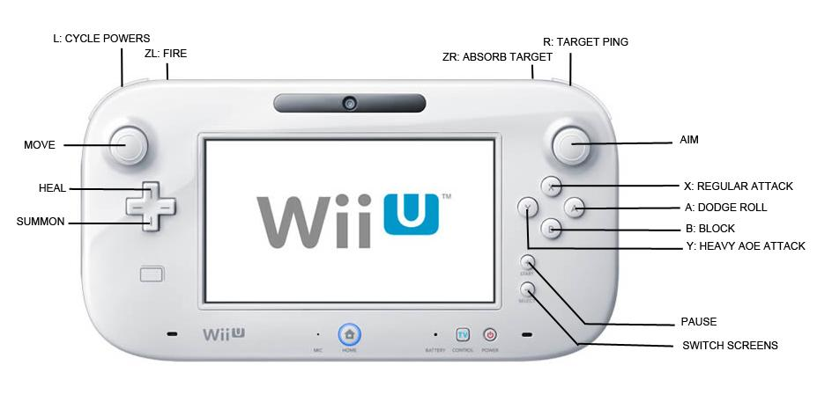

Menus

* Start (+) - Pause menu, with game options & a readout of current troop loadout
* Select (-) - Switches gamepad/TV displays

Movement

* Left stick - Movement of character, fluid 3D movement

Aiming

* Right stick - movement of camera and reticule to aim at troops
* Moves cursor up down left and right

Combat Controls

* A button - Dodge roll
* Y button - wide slash attack around character (AOE)
  + strong attack but slower, meant mostly to knock enemies away when overwhelmed
* X button - Basic sword attack; string 3 into a combo
* B button - Character stops moving and holds sword in front of him to block attacks
* Right Bumper - Selects unit currently targeted; acts as real-time ‘ping’
* Right Trigger - Absorbs targeted allied units as energy
* Left Bumper - Cycles through available powers
* Left Trigger - Use selected power, ‘fire’ absorbed troops
* Directional pad UP - When allies absorbed, sacrifice them to regain player health
* Directional pad DOWN - When allies absorbed, sacrifice them for health
* Direction pad LEFT/RIGHT - Cycle summon
* Start button - Pause game and bring up in game menu
* Select button - Brings up menu that shows all the abilities that the character can do with the different troops
* On controller screen - Orthographic real-time map of the battle that the character is in with color of troops showing ally troops and enemy troops on the battle.

# 

# 

# **8.0 Locations**

Locations in each region transition in three stages: Village, Fortress, Temple. In each region, the player will progress first through the Village stage, clearing out villages. They then move to the Fortress stage where they will have to destroy key locations, before being able to take on the Temple stage, where they will fight the region’s end boss and capture the Sage.

|  |  |  |  |
| --- | --- | --- | --- |
|  | **VILLAGE** | **FORTRESS** | **TEMPLE** |
| **ACT I** | Gerudo Village | Gerudo Valley | Lost Desert Temple |
|  |  |  |  |
| **ACT II** | Lake Hylia | Zora’s Domain | King Jabu Jabu’s Pool |
|  | Goron Mines | Goron City | Death Mountain Summit |
|  | Lost Woods | Kokiri Forest | Great Deku Tree |
|  | Anouki Bay | Frozen Citadel | Iceberg Keep |
|  | Sheikah Training Camp | Sheikah Monastery | Dojo of the Sheik |
|  |  |  |  |
| **ACT III** | Hyrule Field | Hyrule Castle | Sacred Realm Gate |

# 

# 

# 